Keywords: Dollar, scanning,

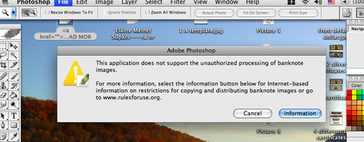

New scanners will not allow anyone to scan any currency. That little add-on was never officially announced, and it is not anywhere in the US legal code.
To scan currency you will need to find a pre 2004 scanner and its software. ( The restriction is in the software for H-P scanners and all-in-ones ) it might be a firmware restriction in other brands.
The same code in in Photoshop and probably other image editing and capturing stand alone software packages also.

